**DAILY ONLINE ACTIVITIES SUMMARY**

|  |  |  |  |  |  |  |  |  |
| --- | --- | --- | --- | --- | --- | --- | --- | --- |
| **Date:** | **12-06-2020** | | | | | **Name:** | **Anix Jugal D’Cunha** | |
| **Sem & Sec** | **8 sem , A sec** | | | | | **USN:** | **4AL16CS013** | |
| **Online Test Summary** | | | | | | | | |
| **Subject** | | **BDA** | | | | | | |
| **Max. Marks** | | **30** | | **Score** | | | **10** | |
| **Certification Course Summary** | | | | | | | | |
| **Course** | **A Practical Guide To Learn Web Development From Scratch** | | | | | | | |
| **Certificate Provider** | | | **Udemy** | | **Duration** | | | 42 mins |
| **Coding Challenges** | | | | | | | | |
| **Problem Statement:** Python program to reverse words in string | | | | | | | | |
| **Status: Competed** | | | | | | | | |
| **Uploaded the report in Github** | | | | | **yes** | | | |
| **If yes Repository name** | | | | | **alvas-education-foundation/dcunhaanixjugal** | | | |
| **Uploaded the report in slack** | | | | | **yes** | | | |

Online Test Details: (Attach the snapshot and briefly write the report for the same)

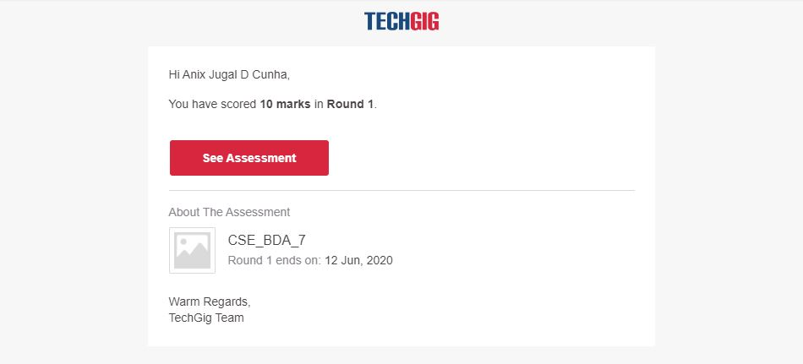

Certification Course Details: (Attach the snapshot and briefly write the report for the same)

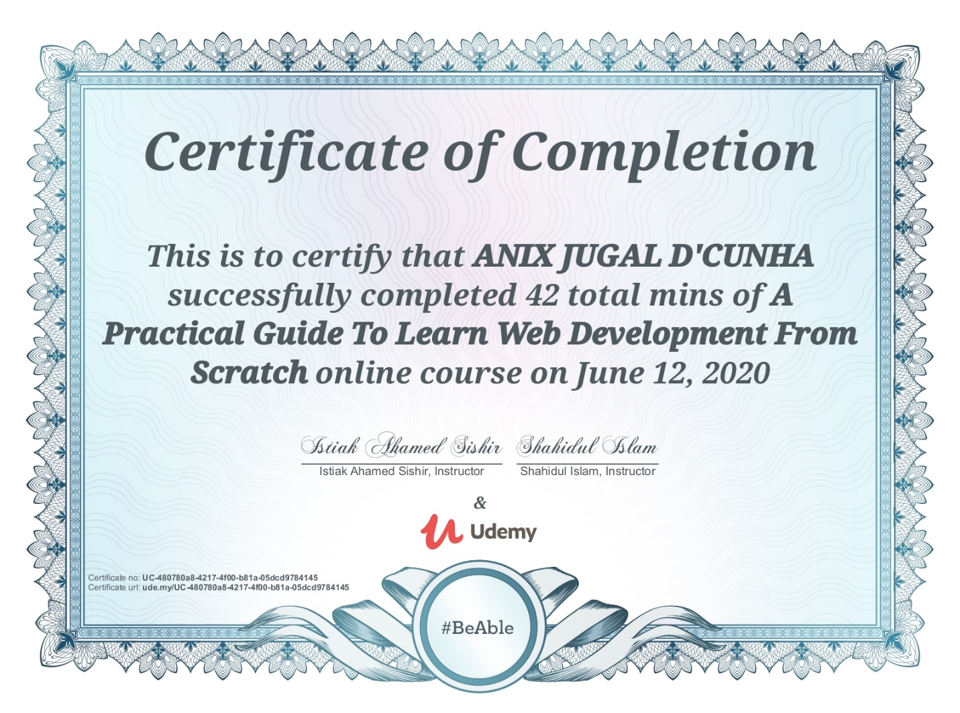

Coding Challenges Details: (Attach the snapshot and briefly write the report for the same)

Program-> Python program to reverse words in string

def reverse_string_words(text):

for line in text.split('\n'):

return(''.join(line.split()[:-1])

print(reverse_string_words("The quick brown fox jumps over the lazy dog.")

print(reverse_string_words("Python Exercises.")